[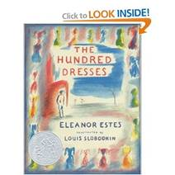](http://www.amazon.com/gp/reader/0152052607/ref=sib_dp_pt#reader-link)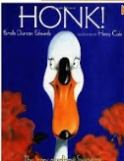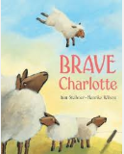[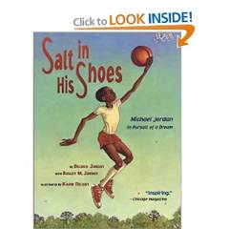](http://www.amazon.com/gp/reader/0689834195/ref=sib_dp_pt#reader-link)[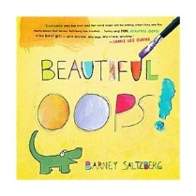](http://www.buy.com/prod/beautiful-oops/214113056.html?listingId=-1&s_kwcid=)[](http://www.amazon.com/gp/product/images/B0042EJ5W4/ref=dp_image_0?ie=UTF8&n=283155&s=books)[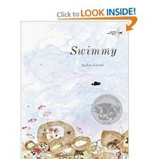](http://www.amazon.com/gp/reader/0394826205/ref=sib_dp_pt#reader-link)[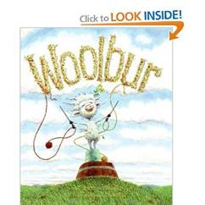](http://www.amazon.com/gp/reader/0060847263/ref=sib_dp_pt#reader-link)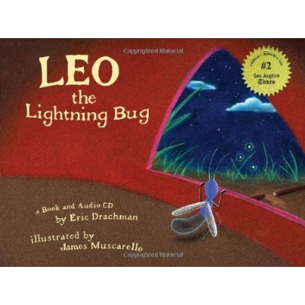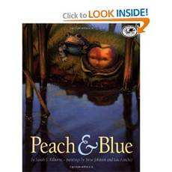

[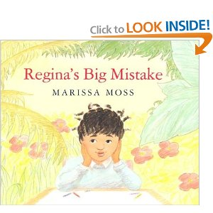](http://www.amazon.com/gp/reader/0395700930/ref=sib_dp_pt#reader-link)

[](http://www.amazon.com/gp/reader/B004WB1A16/ref=sib_dp_pt#reader-link)

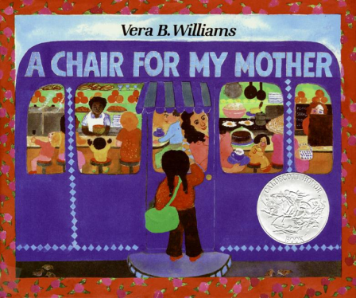

[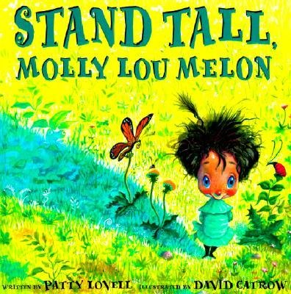](http://www.google.com/url?sa=i&rct=j&q=stand+tall+molly+lou+melon&source=images&cd=&cad=rja&docid=LkVWpbvo2-4Z5M&tbnid=HfdCunSaBP4uKM:&ved=0CAUQjRw&url=http://burningbooksbuffalo.com/product/stand-tall-molly-lou-melon&ei=T18eUcvVLcLk0gHX-IGIDw&bvm=bv.42553238,d.dmQ&psig=AFQjCNGF_gSn-8HVRoWOkmRWAYZbKQMIwA&ust=1361031329563037)[](http://www.amazon.com/gp/reader/0439287197/ref=sib_dp_pt#reader-link)

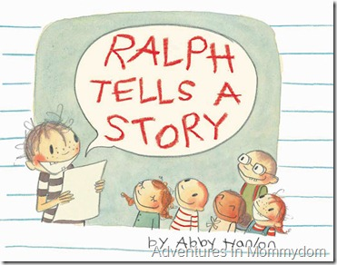[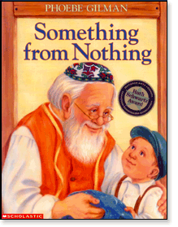](http://www.google.com/url?sa=i&rct=j&q=something+from+nothing+book&source=images&cd=&cad=rja&docid=3ccgax1mh-tmIM&tbnid=vLCZRi_ZGoMRrM:&ved=0CAUQjRw&url=http://www.scholastic.ca/titles/somethingfromnothing/&ei=Bp4eUfaoOoXR0wHDwYGgBw&bvm=bv.42553238,d.dmQ&psig=AFQjCNH92rpw3bK5CMruMjUDIfeHyb4jSA&ust=1361047413107088)[](http://www.google.com/url?sa=i&rct=j&q=The+Art+of+Miss+Chew&source=images&cd=&cad=rja&docid=3-BTOg-seFX6IM&tbnid=c6urBqYdGDNngM:&ved=0CAUQjRw&url=http://picturebookreviews.blog.com/2011/10/23/the-art-of-miss-chew/&ei=5ZgeUd_vDYns0QHFl4DgAg&bvm=bv.42553238,d.dmQ&psig=AFQjCNFClvbcL8oupIWJ7fzZ4VbCnEAXcg&ust=1361046110020379)[](http://www.google.com/url?sa=i&rct=j&q=thank+you+mr.+falker+by+patricia+polacco&source=images&cd=&cad=rja&docid=A9PKXP2h2J3tsM&tbnid=A__AmbaH5kCSoM:&ved=0CAUQjRw&url=http://galleryofportraits.wordpress.com/page/2/&ei=6JseUazMJaq20QHi5oGAAg&bvm=bv.42553238,d.dmQ&psig=AFQjCNG71LrNYT4k-QGCFrG-1gUIrKAzjw&ust=1361046842184797)